**5. Monitor the temperature and gas changes**

**Laboratory work No 3**

1. **Software tool for simulations** [**https://www.tinkercad.com**](https://www.tinkercad.com)

***Tinkercad*** is a free online collection of software tools that help people all over the world think, create and make.It provides usage of Arduino Uno board with list of supported sensors, parts, and C++ IDE for coding. Using Tinkercad, people can create circuit simulations and check how well circuit works before recreating it with actual parts.

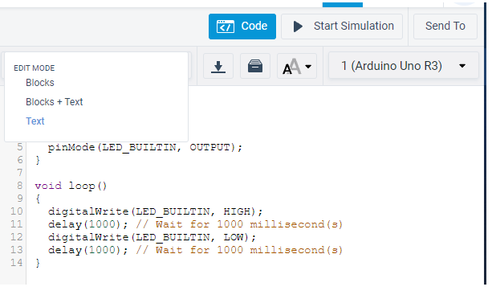Tinkercad provides option to drag-and-drop elements to workspace and connect them using wires. Coding part is located at top right corner of screen (Fig. 1).

Figure 1. **Location of C++ IDE in Tinkercad simulator.**

**You need to create a** [**TinkerCad**](https://www.tinkercad.com) **account for lab work.**

***Join now* 🡪 *Create a personal account***

1. **Laboratory work task**

**Note: To finish this laboratory, 1st and 2nd laboratory tasks needs to be completed.**

Task in this laboratory work is creating circuit that will collect information from **temperature sensor** and **gas sensors**. Depending on values person building get from sensors, “**Danger**” or “**Safe**” message should be shown on **LCD screen**. Additionally, **red LED light** should light up as values passes permitted thresholds. Threshold values can be decided by person building circuit. After setting all elements in simulator, C++ code should be written to add functionality to simulation. If all elements are connected correctly and functionality has been added using C++ code. Simulation can be executed.

Go to ***Circuits*** 🡪 ***Create new circuit***

1. **Additional information for completion of task**

* To finish this laboratory task, 1st and 2nd laboratory tasks need to be finished first.
* Electronic schematic of circuit is provided (Fig. 2, 3). It provides information on one possible way to connect all elements, but not only possible way. So, you can ignore scheme and make your own rendition of circuit. Components – Arduino, LCD I2C, temperature sensor, LED, gas sensor, resistors, breadboard.
* The code can be written in text, blocks and blocks +text.
* To display text or variables on LCD screen, #include <Adafruit_LiquidCrystal.h> library is required, if you follow scheme provided.
* For proper temperature sensor value translation to Celsius degrees specific formula needed for value reading:

<temperature_variable> = map(((analogRead(A0) - 20) * 3.04), 0, 1023, -40, 125;

Figure 2. Connection schematic

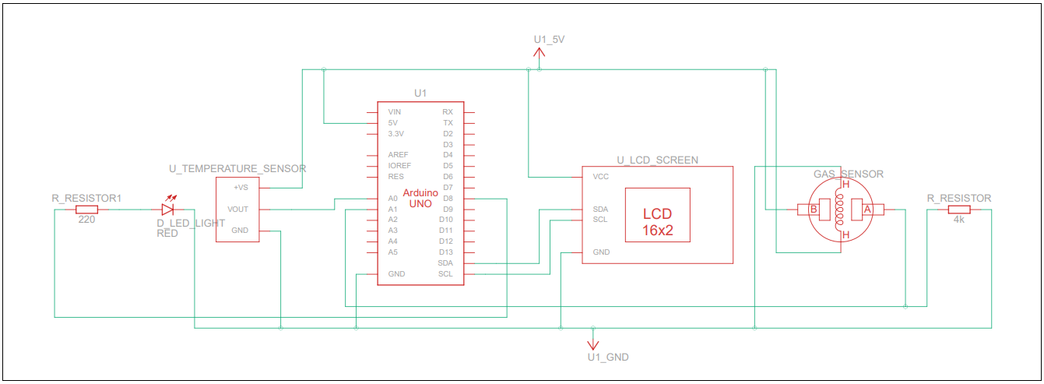

Figure 3. **Arduino Uno circuit for temperature and gas change monitoring**

1. **Submitting results**

After finishing schematic and testing if it works. Submitting of schematic is done by sharing with schematic with person in charge of this laboratory work.

Sharing scheme:

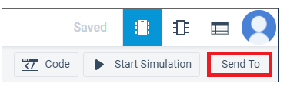1. Press “Send To” button on top right corner of screen (Fig. 4).

Figure 4. **Location of task exportation options**

2. Press button “Invite people” (Fig. 5).

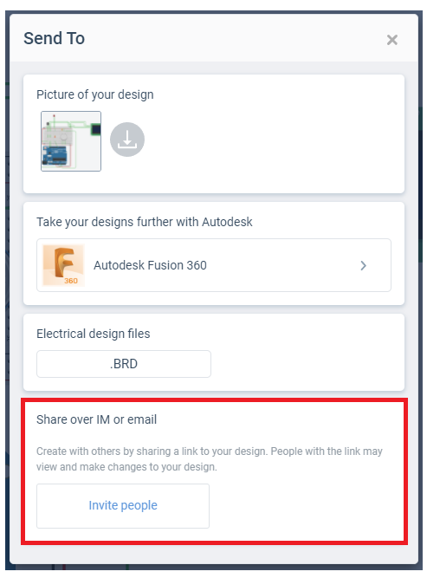

Figure 5. **Sharing completed circuit option**

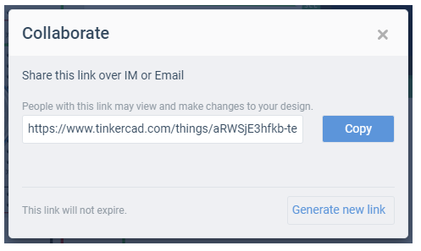3. Copy link and send it to teacher for review (Fig. 6).

Figure 6. **Link to completed circuit to share with teacher**